StudentSurvey1.15.R
garrett
2025-01-15
library(Lock5Data)
data(StudentSurvey)
head(StudentSurvey)
## Year Sex Smoke Award HigherSAT Exercise TV Height Weight Siblings
## 1 Senior M No Olympic Math 10 1 71 180 4
## 2 Sophomore F Yes Academy Math 4 7 66 120 2
## 3 FirstYear M No Nobel Math 14 5 72 208 2
## 4 Junior M No Nobel Math 3 1 63 110 1
## 5 Sophomore F No Nobel Verbal 3 3 65 150 1
## 6 Sophomore F No Nobel Verbal 5 4 65 114 2
## BirthOrder VerbalSAT MathSAT SAT GPA Pulse Piercings
## 1 4 540 670 1210 3.13 54 0
## 2 2 520 630 1150 2.50 66 3
## 3 1 550 560 1110 2.55 130 0
## 4 1 490 630 1120 3.10 78 0
## 5 1 720 450 1170 2.70 40 6
## 6 2 600 550 1150 3.20 80 4
table.f=table(StudentSurvey$Sex, StudentSurvey$Award)
table.f
##
## Academy Nobel Olympic
## F 20 76 73
## M 11 73 109
two.way.table=addmargins(table.f);two.way.table
##
## Academy Nobel Olympic Sum
## F 20 76 73 169
## M 11 73 109 193
## Sum 31 149 182 362
popul=max(two.way.table[3, 1:3])
popul
## [1] 182
phat=popul/two.way.table[3,4]; phat
## [1] 0.5027624
barplot(table.f)
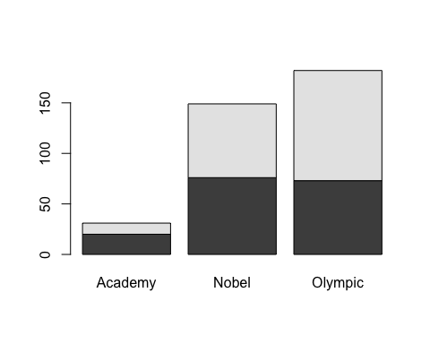
table.f.a=table(StudentSurvey$Award, StudentSurvey$Sex)
barplot(table.f.a)
